**高雄醫學大學毒性及關注化學物質管理規則**

**Kaohsiung Medical University**

**Regulations for Toxic and Concerned Chemical Substances Control**

88.11.23　毒性化學物質管理委員會會議通過

89.03.30　八十八學年度法規委員會第九次會議通過

91.07.09　九十學年度毒性化學物質運作管理委員會修改

111.01.13　110學年度第1次毒性化學物質管理委員會通過

November 23, 1999 Passed by the Toxic Chemical Substances Management Committee meeting

March 30, 2000 Passed by the 9th meeting of the Regulations Committee in Academic Year 1999-2000

July 9, 2002 Amended by the Operational Management Committee for Toxic Chemical Substances in

Academic Year 2001-2002

January 13, 2022 Passed by the 1st Toxic Chemical Substances Management Committee in Academic Year

2021-2022

| 第1條  Article 1 | 依據行政院環境保護署「學術機構毒性及關注化學物質管理辦法」第3條規定訂定本規則。  Kaohsiung Medical University (KMU) formulates the Regulations for Toxic and Concerned Chemical Substances Control in accordance with Article 3 of the Regulations Governing Management of Toxic and Concerned Chemical Substances at Academic Institutions by the Environmental Protection Administration, Executive Yuan. |
| --- | --- |
| 第2條  Article 2 | 本校各單位購買、使用毒性及關注化學物質，應送環境保護暨職業安全衛生衛生室（以下簡稱環安室）安全衛生組申請，經安全衛生組組長或環安室主任核可後，方可購買。  For purchase and use of toxic and concerned chemical substances by all units of KMU, an application shall be sent to the Health and Safety Section of the Office of Environmental Protection, Occupational Safety and Health (EHS). Purchase can be made only after getting approval from the Chief of the Health and Safety Section or Director of EHS.  本校各單位廢棄毒性及關注化學物質，應先經毒性及關注化學物質委員會（以下簡稱本委員會）審議通過後，由安全衛生組呈校長核定並報請主管機關登記備查或核可，且副知各該主管教育行政機關。  For disposal of toxic and concerned chemical substances by all units of KMU, the Toxic and Concerned Chemical Substances Management Committee (TCCSMC) shall review and pass the request first, and then the Health and Safety Section shall submit it to the President for approval and file with the competent authority for registration and reference, or for approval. All education bureaus shall be put on copy.  前項廢棄前之貯存行為，得貯存於運作之實驗單位內。  Before making the disposal as mentioned in the preceding paragraph, the substances shall be stored inside the handling laboratory.  各單位除依毒性及關注化學物質管理法第21條規定外，不得將毒性及關注化學物質販賣或轉讓他人。  Toxic and concerned chemical substances shall not be sold or transferred to others except under the conditions prescribed in Article 21 of the Toxic and Concerned Chemical Substances Control Act. |
| 第3條  Article 3 | 第3條  Article 3  毒性及關注化學物質之運作場所及設施，應於易取得之處，置備安全資料表，其容器及包裝並依下列規定標示：  Venues and facilities that handle toxic and concerned chemical substances shall make the safety data sheets available at an easily accessible place, with container or packaging that is labeled according to the following specifications:   1. 毒性及關注化學物質之容器、包裝，應符合中華民國國家標準CNS 15030及本規則之附表等所定分類、標示要項，(本附表參照行政院環保署毒性及關注化學物質標示與安全資料表管理辦法之附表格式)，並依其附表格式明顯標示下列事項：   1. Containers and packaging of toxic and concerned chemical substances shall be in compliance with the classification and labeling requirements of the Chinese National Standards (CNS) 15030 and the appended table of these Regulations, and clearly indicate the following items in the specified format of the appended table. (This table is made with reference to the Attached Table Labeling Format of the Regulations for the Labeling and Safety Data Sheets for Toxic and Concerned Chemical Substances by the Environmental Protection Administration, Executive Yuan):   * 1. 危害圖式：直立四十五度角之白底紅色粗框正方形，內為黑色象徵符號，大小以能辨識清楚為度。   （1）Pictograms: A square presented at a 45° angle to the vertical direction consisting of a red outline on a white background. The interior of the square should contain a suitable sized black symbol for identification.   * 1. 內容：   （2）Contents:   * + 1. 名稱。   (1) Name.   * + 1. 危害成分：所含毒性化學物質達管制濃度以上之成分，應以中央主管機關公告之名稱（中英文）標示，並加註毒性化學物質等字樣及所含毒性化學物質重量百分比（w/w）。   (2) Hazardous Ingredients: All toxic and concerned chemical substances exceeding the control concentration shall be labeled with the Chinese and English names announced by the central competent authority. The words “toxic chemical substances” or “concerned chemical substances” and the weight percentages of the substances contained therein shall be stated.   * + 1. 警示語或警語。   (3) Signal Words or Warnings.   * + 1. 危害警告訊息。   (4) Hazard Statements.   * + 1. 危害防範措施。   (5) Precautionary Statements.   * + 1. 製造者、輸入者或供應者名稱、地址及電話。   (6) Name, address, and telephone number of the manufacturer, vendor, or supplier.  前款標示如其物質危害特性不符合中華民國國家標準CNS 15030規定之分類歸類者，得僅標示前款第二目事項。  For the label described in the preceding subparagraph, if the substances do not conform to the classification of the Chinese National Standards CNS 15030 due to their hazardous characteristics, only the information in Item (2) above should be labeled.  前款容器、包裝容積在一百毫升以下者，得僅標示名稱、危害圖式及警示語。  Containers or packaging less than 100 milliliters specified in the preceding subparagraph may be marked only with the name, hazard pictograms, and signal words.  二、毒性及關注化學物質之運作及其釋放量，運作人應製作紀錄定期申報，其紀錄應妥善保存備查。  2. For the handling of toxic and concerned chemical substances and the amount of release, the handler shall produce records and make regular reports, and the records shall be properly kept for reference. |
| 第4條  Article 4 | 各單位使用毒性及關注化學物質，應於每年1、4、7、10月之15日前將各實驗室運作記錄傳輸至教育部化學品申報系統申報。環安室彙整後於每年1月31日、4月30日、7月31日、10月31日前，向毒性及關注化學物質所在地之主管機關申報前三個月毒性化學物質運作紀錄表。  All units that use toxic and concerned chemical substances shall transmit all the lab handling records to the Ministry of Education’s Chemical Substance Reporting System before the 15th of January, April, July, and October each year. The Office of Environmental Protection, Occupational Safety and Health shall compile the records and then report the toxic chemical substances handling records for the preceding 3 months to the local competent authority in charge of toxic and concerned chemical substances before January 31st, April 30th, July 31st, October 31st each year.  前項運作紀錄應於運作場所書面或電子檔案方式保存三年備查。  The handling records mentioned in the preceding paragraph shall be kept at the handling venues in written form or electronic file for 3 years for reference. |
| 第5條  Article 5 | 本規則經本委員會審議通過後，自公布日起實施，修正時亦同。  These Regulations shall be reviewed and passed by the TCCSMC and then implemented on the date of promulgation and shall apply to subsequent amendments. |

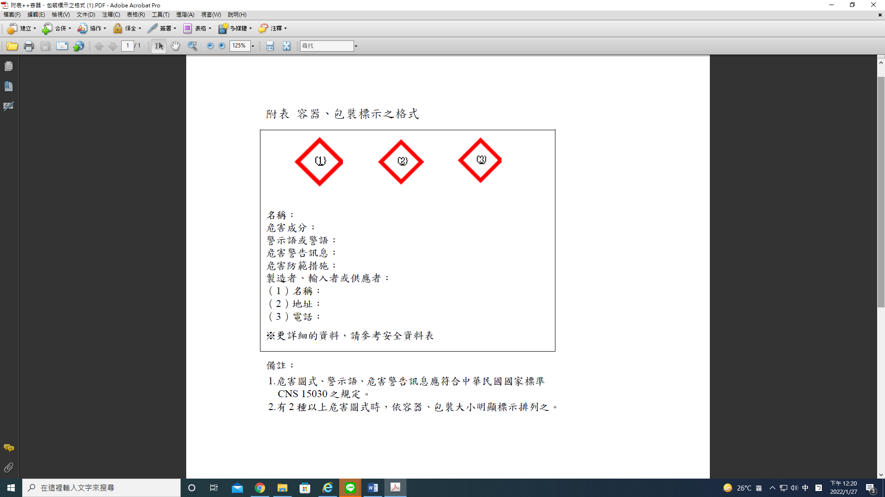

附表 容器、包裝標示之格式

Appended Table Labeling Format for Container and Packaging

名稱：

Name:

危害成分：

Hazardous Ingredients:

警示語或警語：

Signal Words or Warnings:

危害警告訊息：

Hazard Statements:

危害防範措施：

Precautionary Statements:

製造者、輸入者或供應者：

Manufacturer, Importer, or Supplier:

(1) 名稱：

(1) Name:

(2) 地址：

(2) Address:

(3) 電話：

(3) Telephone:

፠ 更詳細的資料，請參考安全資料表

፠ Please refer to the safety data sheets for more information.

備註：

Remarks:

1. 危害圖式、警示語、危害警告訊息應符合中華民國國家標準CNS 15030之規定。

1. Pictograms, Signal Words, Hazard Statements should comply with the Chinese National Standards CNS 15030.

2. 有2種以上危害圖式時，依容器、包裝大小明顯標示排列之。

2. If there are 2 or more pictograms, they should be arranged in accordance with the size of container or packaging so as to show clearly and visibly.